Apache CXF Step by Step

Creating Service using CXF

- Create a dynamic web project in eclipse .And the package structure should look like :
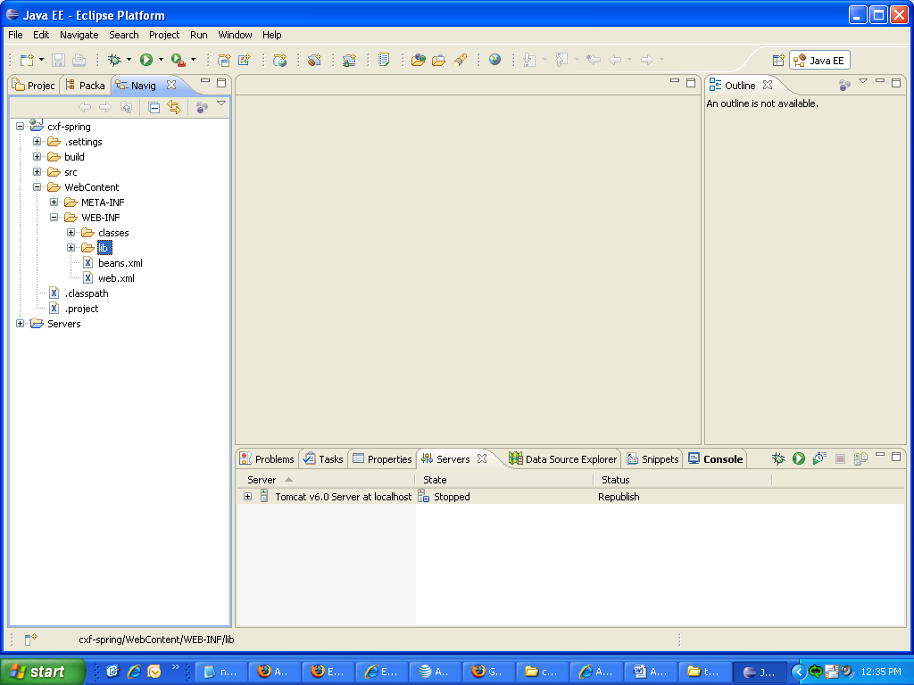

- Please load the required jar files:
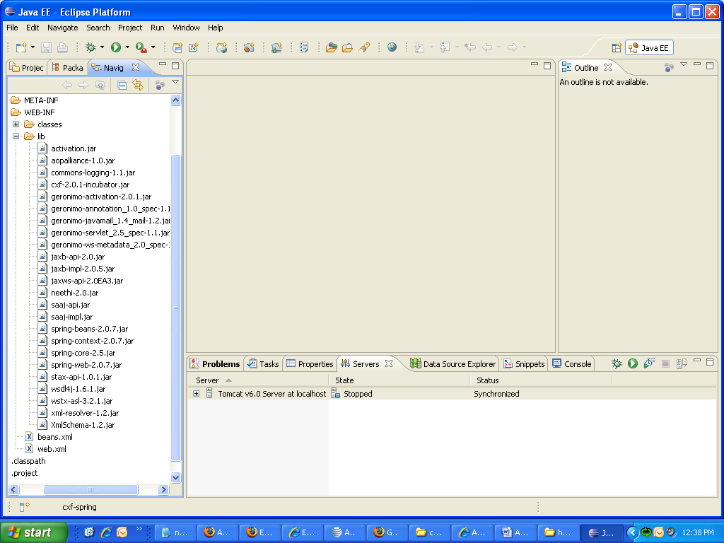

3.Add the following classes in source folder

HelloWorld.java

package demo.spring;

import javax.jws.WebService;

@WebService
public interface HelloWorld {
String sayHi(String text);
}

HelloWorldImpl.java

package demo.spring;

import javax.jws.WebService;

@WebService(endpointInterface = "demo.spring.HelloWorld")
public class HelloWorldImpl implements HelloWorld {

public String sayHi(String text) {
System.out.println("sayHi called" + " " + "text value is" + " "
+ text);
return "Hello " + text;
}
}

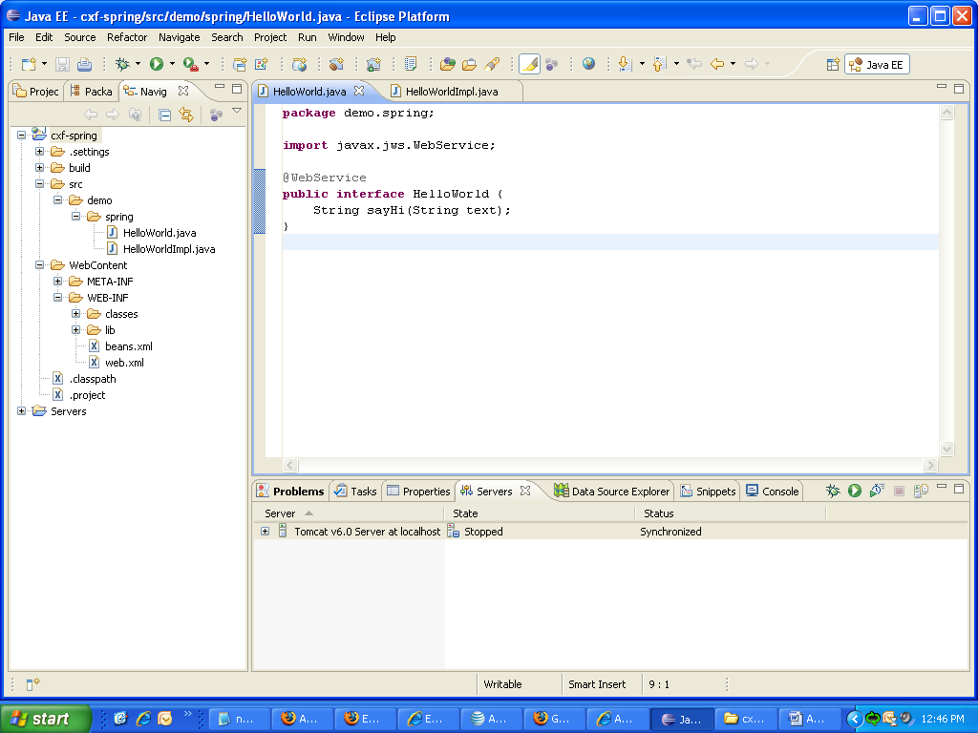

4. Declaring your server beans, add this beans.xml file in WEB-INF folder.

<?xml version="1.0" encoding="UTF-8"?>
<beans xmlns="http://www.springframework.org/schema/beans"
xmlns:xsi="http://www.w3.org/2001/XMLSchema-instance"
xmlns:jaxws="http://cxf.apache.org/jaxws"
xsi:schemaLocation="
http://www.springframework.org/schema/beans http://www.springframework.org/schema/beans/spring-beans.xsd
http://cxf.apache.org/jaxws http://cxf.apache.org/schemas/jaxws.xsd">

<import resource="classpath:META-INF/cxf/cxf.xml" />
<import resource="classpath:META-INF/cxf/cxf-extension-soap.xml" />
<import resource="classpath:META-INF/cxf/cxf-servlet.xml" />

<jaxws:endpoint id="helloWorld"
implementor="demo.spring.HelloWorldImpl" address="/HelloWorld" />

<!-- <bean id="hello" class="demo.spring.HelloWorldImpl" />

<jaxws:endpoint id="helloWorld" implementor="#hello"
address="/HelloWorld" /> -->

</beans>

**If you want to reference a spring managed-bean, you can uncomment the code and comment
<jaxws:endpoint id="helloWorld"
implementor="demo.spring.HelloWorldImpl" address="/HelloWorld" />
this code.

5. Setting up the Servlet:

- the Spring ContextLoaderLister. This starts Spring and loads our beans.xml file. We can specify where our file is via a context-param element.

Web.xml

<?xml version="1.0" encoding="UTF-8"?>
<web-app>
<context-param>
<param-name>contextConfigLocation</param-name>
<param-value>WEB-INF/beans.xml</param-value>
</context-param>

<listener>
<listener-class>
org.springframework.web.context.ContextLoaderListener
</listener-class>
</listener>

<servlet>
<servlet-name>CXFServlet</servlet-name>
<display-name>CXF Servlet</display-name>
<servlet-class>
org.apache.cxf.transport.servlet.CXFServlet
</servlet-class>
<load-on-startup>1</load-on-startup>
</servlet>

<servlet-mapping>
<servlet-name>CXFServlet</servlet-name>
<url-pattern>/*</url-pattern>
</servlet-mapping>
</web-app>

6. After the above steps have been done , now right click on project and run on server).

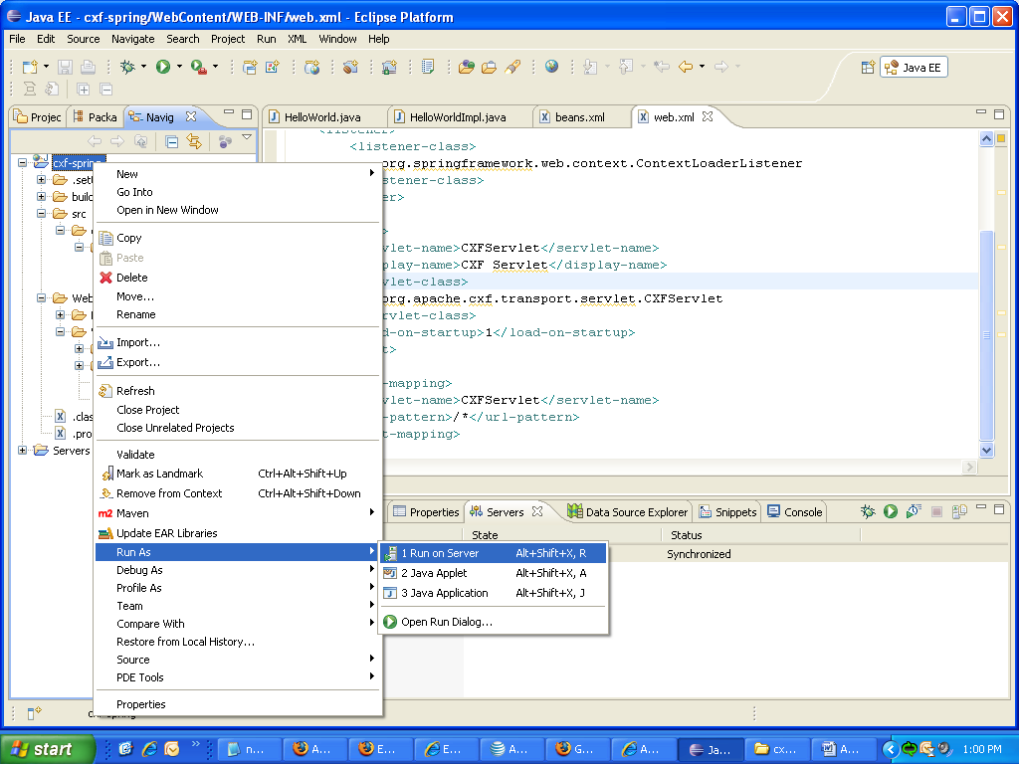

7.The wsdl will be generated.
